N Unit 5

- Layers of the Atmosphere –
  - Made of 8 gases (mostly nitrogen 78% and oxygen 21%)
  - Classified by temperature, density and air pressure
  - Identified by altitude
    - Troposphere Most dense, greatest air pressure, closest to earth
    - Stratosphere
    - Mesosphere
    - Thermosphere
    - Exosphere Least dense, lowest air pressure, farthest from
earth
  - Temperature fluctuates
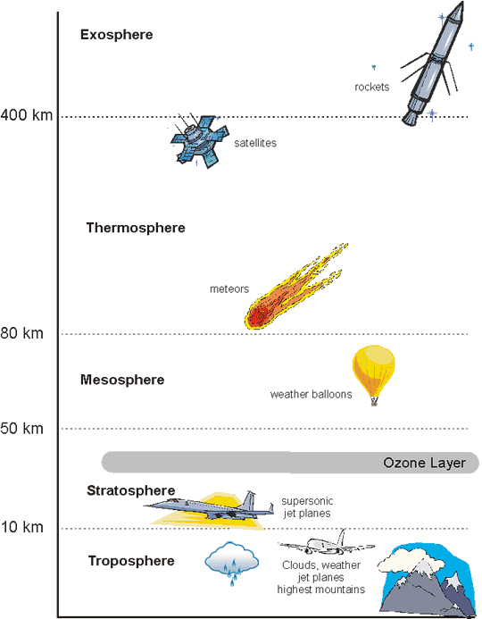
- Heat Transfer
  - Conduction – heat transfers from warm to cold by direct contact. Can be heat from water or land to air – heating up the air.
  - Convection – the circulation of heat - happens in liquid or gas – warm rises, cool sinks
  - Radiation – heat energy emitted from one body, travels through a space and is absorbed by another body. EX: fireplace, sun
- Daily Weather
  - Water has three stages: Solid (ice), liquid (water), and gas (water vapor)
  - Heat changes these stages.
    - Heat added – molecules move faster!
    - Heat removed – molecules move s-l-o-w-e-r
  - Factors of Weather
    - Temperature – Earth heats unevenly (warmer at the equator – cooler at the poles)
    - Humidity – water vapor in the air.
      - High humidity – lots of water vapor! Air is warmer
      - Low humidity – low water vapor! Cooler air
      - Relative humidity – how much water vapor is in the air in relation to how much water vapor the air can hold at that temperature. As the temperature goes up, the relative humidity goes down.
    - Wind – moving air
      - Heat affects spaces between air particles
      - Heat = more energy in air (just like with water). Heated air moves and expands, becomes less dense and rises
      - Air moves in groups called convection cells
    - Air Pressure – CAUSES WIND!
      - Low Pressure
        - Warm, humid air full of water vapor
        - Rises
        - Brings bad weather conditions
      - High Pressure
        - Cold, dry air
        - Falls/sinks
        - Brings happy, nice weather
      - Air Pressure Gradient – change in air pressure between two air masses.
        - Steeper gradient = faster, stronger wind
- Coriolis Effect
  - As air is circulating in convection cells, the earth is rotating. This causes wind to veer to the east or west.
  - Air moving from the equator to the poles moves faster and veers to the east.
  - Air moving from the poles to the equator moves slower and veers to the west.
- Friction
  - Friction between air molecules and Earth’s surface slows air down
- Air Masses – large section of air with same temperature, pressure and humidity
  - Polar – COLD
  - Tropical – WARM
  - Continental –DRY
  - Maritime – HUMID
  - WARM air masses – travel toward the poles
    - Maritime Tropical - low pressure, low density, bring humid/ muggy weather
    - Continental Tropical – greater pressure, greater density, bring warm, dry weather
  - COLD air masses – travel toward the equator
    - Maritime Polar – low pressure, low density, cold and humid weather
    - Continental Polar - greater pressure, greater density, cold and dry weather
    - Artic - greater pressure, greater density, extremely cold and dry
- Fronts – when two air masses meet at their boundary
  - Warm front – warm, humid air presses forward – pushes cold air back
    - Bring drizzly weather
  - Cold front – cold, dry air pushes forward - pushes warm air up and back
    - Brings storms!
  - Stationary front – at a standstill.
    - Brings gray skies, rain or snow lasting several days
  - Occluded front – warm air gets stuck between two cold fronts
    - Brings light to heavy precipitation that may last several days
- Meteorologist – scientist who studies weather
  - Uses radar, weather balloons and satellites to measure air pressure, temperature, humidity levels, etc.
  - Barometer – measures air pressure
    - High pressure – mercury goes up
    - Low pressure – mercury goes down
  - Hygrometer – measures humidity in the air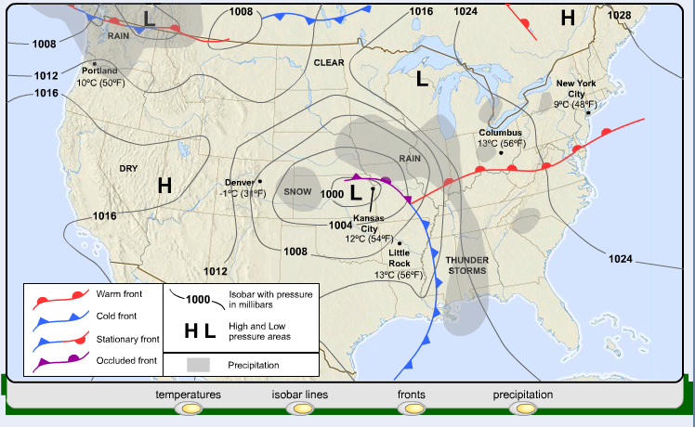
- Climate – average weather conditions of an area long term (temperature and precipitation levels)
  - Polar – Cold and dry
  - Temperate – Moderate – seasons
  - Tropical – Hot, humid with lots of rainfall
  - Changes in climate are caused by:
    - Latitude – distance from the equator. The closer to the equator, the higher the temperature
    - Ocean currents AND proximity to a body of water– often windy by the sea.
      - Air is warmer above land than above water – the difference in air temperature causes wind.
      - Ocean winds carry moisture, bring rain and fog
      - Ocean currents bringing in warm water or cold water – which then brings in warm or cold air as well
    - Mountains – block wind and can affect precipitation
      - Windward – wind facing side
      - Leeward – down wind side
      - When moisture hits the windward side of the mountain – rain or snow falls because the air is forced to rise and cool – this releasing moisture.
      - By the time the wind reaches the other side of the mountain, it is mostly dry and cool.
- Global Warming – a trend showing that the average temperature of Earth’s atmosphere is increasing.
  - Greenhouse Effect – Energy from the sun is absorbed by Earth’s surface converted to heat and released into the atmosphere
  - Clouds and gases trap rising heat and redirect it back to the Earth’s surface – heating up the earth.
  - Greenhouse gases –
    - Naturally occurring - water vapor, nitrous oxide (N₂O), carbon dioxide (CO₂), methane, and the ozone gases.
    - Manmade – chlorofluorocarbons (CFCs) and carbon dioxide (CO₂). (CO₂ is both natural and manmade.)
      - Destroy the Ozone

