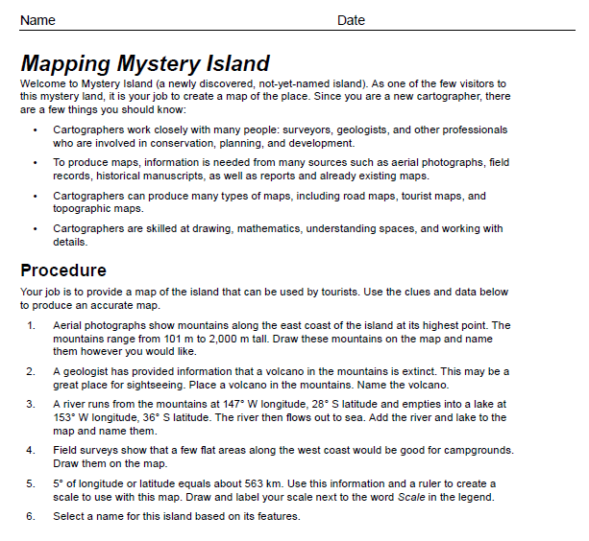

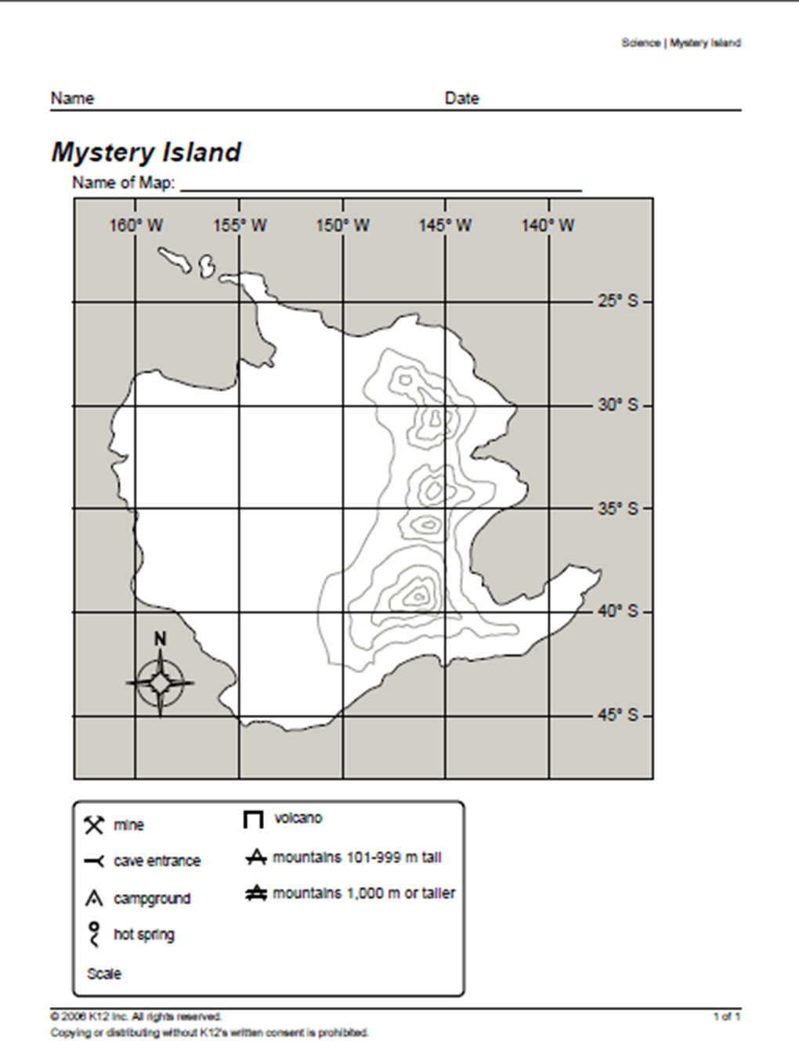
How my project will be graded!
GOES ALONG WITH PAGES 49 and 50 in your student pages book for Science
- Mountains:
Location 1 point
Name 1 point
Symbol 1 point
- Volcano:
Location 1 point
Name 1 point
Symbol 1 point
- River and lake:
Location 4 points
Name 2 points
Direction 1 point
- Campground
Location 1 point
Symbol 1 point
- Scale
Correct length 1 point
Correct location 1 point
- Island name
Name 1 point

Total points 18 points earned ______
**Please kmail finished projects to Mrs. Oakes OR send them through traditional mail at:
Casey Oakes
167 A Richland Carlisle, PA 17015

